Key Stage 2 Home Learning - Year 4 - Week Beginning: 20.04.20
Weekly Topics  - Maths: Place value and numbers to 10,000, including counting in equal steps; mental addition and subtraction (Spring Term week 11). https://www.activelearnprimary.co.uk/start.  - Literacy Writing: On the Prowl (shared on hwb account)  - Literacy Reading: Read the book called: Changing Places on https://www.activelearnprimary.co.uk/start.  - Cymraeg: Scan the QR code for this week’s Welsh games. Also look at Pennard Primary’s Twitter Page for more Welsh games – There is a Kahoot you can play, and winners will be announced on Pennard Press. |  | 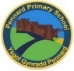  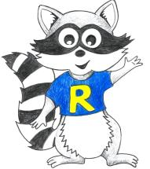
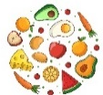
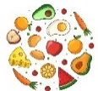
Inquiry Based Learning - Gut Reaction
(This activity is to last the whole week)
Explore the types of food you eat each day – keep a diary! Research what a food pyramid is and draw it into your book or upload it onto hwb. You need to research what a healthy and balanced diet is; using real food and food packaging, draw your food pyramid for the week from your food diary. How does it compare to the food pyramid you researched? Do you have a healthy balanced diet?
Challenge: Make your healthiest meal and take photograph!
Monday | - Maths: Pair them all up activity & Football Fans  - Literacy Writing: Story Starter – Continue writing the story  - Active: Yoga https://www.youtube.com/watch?v=02E1468SdHg
Tuesday | - Maths: Lizard Sums & Tell the Teacher  - Literacy Comprehension: Question Time & Sick Sentences.  - Active: PE with Joe Wicks daily https://www.youtube.com/channel/UCAxW1XT0iEJo0TYlRfn6rYQ
Wednesday | - Maths: Always, Sometimes, Never – choose a level.  - Literacy Grammar and Punctuation: Sentence Challenge  - Active: Yoga https://www.youtube.com/watch?v=02E1468SdHg
Thursday | - Maths: Homework Sheet 4.11  - Literacy Spelling: Unit 20 – igh, augh and ough letter strings Active: PE with Joe Wicks daily. https://www.youtube.com/channel/UCAxW1XT0iEJo0TYlRfn6rYQ
Friday | - Maths: Cloud Clash Game – see if you can get to Gold! J  - Literacy Writing: Perfect picture drawing  - Active: Dance Mat Typing: https://www.bbc.co.uk/bitesize/topics/zf2f9j6/articles/z3c6tfr

