Key Stage 2 Home Learning - Year 4 - Week Beginning: 29.6.20 (Group 1)
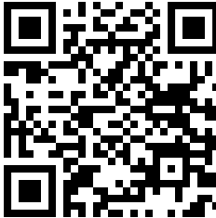  - Maths: The Distributive Law & Multiplication  - Reading: https://www.activelearnprimary.co.uk/start  - Writing: Catch a Lot - https://youtu.be/OAji8DILjFs shared on hwb and PowerPoint on Pennard Primary Website  - Cymraeg: Scan the QR code for this week’s Welsh games. Also look at Pennard Primary’s Twitter Page for more Welsh games – There is a Kahoot you can play, and winners will be announced on Pennard Press. |  |  |  | 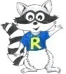
Monday | Maths  The Distributive Law  Chapter 1 -4  www.mymaths.co.uk | Literacy  Catch a Lot – watch video and answer questions.  https://youtu.be/OAji8DILjFs  (Shared on hwb) | Wellbeing  Yoga  https://www.youtube.com/watch?v=02E1468SdHg
Tuesday | Maths  The Distributive Law  Chapter 5-9  www.mymaths.co.uk | Literacy  Synonyms  (Shared on hwb) | Wellbeing  PE with Joe Wicks daily  https://www.youtube.com/channel/UCAxW1XT0iEJo0TYlRfn6rYQ
Wednesday | Maths  Target sheet 1 & 2  (Worksheet Shared on hwb) | Literacy  Pathetic Fallacy  (Shared on hwb) | Wellbeing  Yoga  https://www.youtube.com/watch?v=02E1468SdHg
Thursday | Maths  Target sheet 3  (Worksheet Shared on hwb) | Literacy  Descriptive Writing  (Shared on hwb) | Wellbeing  PE with Joe Wicks daily.  https://www.youtube.com/channel/UCAxW1XT0iEJo0TYlRfn6rYQ
Friday | Maths  Target sheet 4  (Worksheet Shared on hwb) | Literacy  Spelling: Silent Letters https://www.activelearnprimary.co.uk/start | Dance Mat Typing  https://www.bbc.co.uk/bitesize/topics/zf2f9j6/articles/z3c6tfr
Inquiry Based Learning – Message in a bottle!
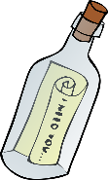
Imagine you are one of the characters from the film. After the whale tries to eat you, you find yourself washed up on a strange island. Write a message to put into a bottle to explain how you got there. You could make the paper look old and ask your mum and dad for an old bottle to put it in! Take a picture and send it to me.
Challenge: Imagine that the clip you watched was part of a story book. Create a front cover for the book to show what the book is about. You could use J2E to create it or make a giant cover on card and use paints and stick things on!!

