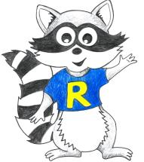
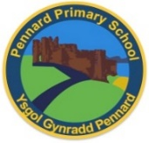
Key Stage 2 Home Learning
Year 3 - Week Beginning: 20.04.20
Weekly Topics  Maths: Understanding Place value and Properties of  Numbers (Spring Term week 11):  https://www.activelearnprimary.co.uk/start.  Literacy Reading (storybook): Title: ‘Changing Places’ by  Nette Hilton: https://www.activelearnprimary.co.uk/start.  Literacy Writing: On the Prowl: On the prowl.pdf  Cymraeg: Scan the QR code for this week’s  Welsh games.  Also look at Pennard Primary’s Twitter Page for more  Welsh games. |  | 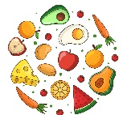  Inquiry Based Learning  Gut Reaction  (This activity is to last the whole week)  Explore the types of food you eat each day – keep a diary!  Research what a food pyramid is and draw it into your book or upload it onto hwb. You need to research what a healthy and balanced diet is; using real food and food packaging, draw your food pyramid for the week from your food diary. How does it compare to the food pyramid you researched? Do you have a healthy balanced diet?  Challenge: Make your healthiest meal and take photograph!
Monday | Maths: Spoon and folk Maths + Counter place value.  - Literacy Writing: Story Starter – Continue writing the story.  - Active: Yoga https://www.youtube.com/watch?v=02E1468SdHg
Tuesday | - Maths: Shark sums + Paw prints.  - Literacy Comprehension: Question Time – answer the questions!  - Active: PE with Joe Wicks daily https://www.youtube.com/channel/UCAxW1XT0iEJo0TYlRfn6rYQ
Wednesday | - Maths: Counting in 10’s and 100’s – choose a level! ☺  - Literacy Grammar and Punctuation: Sentence Challenge & Sick Sentences.  - Active: Yoga https://www.youtube.com/watch?v=02E1468SdHg
Thursday | - Maths: Homework Sheet 3.11.  - Literacy Spelling: Unit 20 – Roots, prefixes and suffixes.  - Active: PE with Joe Wicks daily. https://www.youtube.com/channel/UCAxW1XT0iEJo0TYlRfn6rYQ
Friday | - Maths: Clam collector – choose a level! ☺  - Literacy Writing: Perfect picture drawing.  - Active: Dance Mat Typing: https://www.bbc.co.uk/bitesize/topics/zf2f9j6/articles/z3c6tfr

